SUITABILITY ANALYSIS OF POTENTIAL SOLAR POWER FARMS IN WESTERN SAUDI ARABIA

By Muhammad Areeb,

10th December, 2024

GIST Capstone Project 2024

**Contents**

ETHICS STATEMENT 4

ABSTRACT 5

INTRODUCTION 5

METHODOLOGY AND DATA 7

Workflow 8

Study Area and Data Sources 9

Photovoltaic Potential (PV) 10

Temperature 11

Proximity to Roads and Electric Grid 13

Elevation, Slope and Aspect 15

Analytic Hierarchy Process 16

Constraints Layer 17

RESULTS AND DISCUSSION 20

Parameter Assessment 20

Constraints Layer 20

Analytic Hierarchy Process (AHP) 21

CONCLUSION 23

REFERENCES 24

**List of Figures and Tables**

Figure 1: Energy Consumption Saudi Arabia 6

Figure 2: MCDA Workflow 8

Figure 3: Study Area (Western Provinces of KSA) 9

Figure 4: Saudi Solar PV Potential 11

Figure 5: Saudi Arabia average temperature 12

Figure 6: Proximity to Road Networks 13

Figure 7: Proximity to Electric Grid 14

Figure 8: Saudi Arabia Slope and Aspect 16

Figure 9: LULC 18

Figure 10: Constraints Layer 21

Figure 11: Suitability Model 22

Figure 12: Best Suitability Model 23

Table 1: Data Sources 10

Table 2: AHP 17

Table 3: Restricted Classes 19

# ETHICS STATEMENT

GIS (Geographic Information Science) has evolved significantly throughout history. Before the Information Age, GIS existed in simpler forms, such as cartography and basic map-making. Early image capturing—now evolved into photography and remote sensing—also contributed to its development, from Joseph Nicéphore Niépce’s heliography to images taken at White Sands Missile Range by launching a 35mm camera into space (Musée Nicéphore Niépce, n.d.; C.Holiday, 2019).

Centered around maps, GIS has driven scientific innovation and improved our understanding of Earth's physical processes. However, the quality and transparency of collected data are critical. GIS professionals must address ethical concerns, including proper metadata usage and acknowledging dataset inaccuracies. It’s essential to cite credible scientific sources, prioritizing institutional references over less reliable options like news articles or Wikipedia (Thompson et al. n.d).

Key ethical considerations for this project include accurate source citation and avoiding plagiarism, particularly amidst "citation farming," where frequently cited information gains false credibility. Sources have been identified and questionable sources have been clarified. Additionally, to avoid bias, the project’s parameters have remained realistic, even when favoring one geographic location, to prevent exaggerated results (American Statistical Association, 2022).

# ABSTRACT

# The Kingdom of Saudi Arabia is undergoing a major transformation in its economic, social, and energy landscape, driven by the ambitious goals outlined in Vision 2030. This project focuses on conducting a suitability analysis for potential solar energy project locations in the western region of KSA, which has the highest energy consumption. The analysis aims to identify optimal locations for these projects to contribute to the national energy goals and support Saudi Arabia's economic diversification efforts.

Saudi Arabia is in an advantageous situation regarding this, as it doesn't necessarily need to store the access energy right now but could instead use this energy to perform thermal desalination, reducing the energy consumption of fossil fuels.

This research serves a dual purpose—to meet the renewable energy plans and demands of the increasing population in a sustainable way, and to substitute an existing energy source for seawater desalination.

# INTRODUCTION

Saudi Arabia's Vision 2030 is a blueprint to diversify its economy away from oil and natural gas. With abundant sunlight throughout the year and only about 1.5% of the total area being arable land, most of the country being a desolate desert (The World Factbook, n.d), it presents an opportunity to establish large-scale solar farms. Vision 2030 aims to produce energy up to 50% from renewable sources by 2030 (Vision 2030, n.d; Rahaf Jambi, 2024).

The decrease in prices of solar PVs and the increasing viability of Renewable Energy Sources (RES) indicated by declining Levelized Cost of Energy (LCOE) values for different solar energy resources, along with Saudi Arabia's ranking in the top ten for highest radiation in different solar radiation categories and government incentives, make it logical for the country to expand its energy portfolio. Currently, ~99% of energy generation is based on fossil fuels, with renewable energy accounting for only a small fraction of the total capacity (World Bank, 2020; Lazard, 2024).

The western region of Saudi Arabia has been chosen as the focus area for this analysis due to its high energy consumption, primarily driven by the Islamic pilgrimage in Makkah and Madinah. With the commitment of Vision 2030 and the supportive factors of high solar radiation and declining solar PV costs, the western region presents a strategic area for the development of solar energy projects. Saudi Arabia has set ambitious targets for renewable energy capacity. The country aims to increase its renewable energy generation to 130GW by 2030, which would require adding more than 20GW per year. Despite these ambitious targets, progress has been slower than initially planned. As of 2023, Saudi Arabia had only about 1.5GW solar renewable energy capacity, far below the 24GW, it was supposed to have by 2020 (energymonitor, 2023).

This suitability analysis will contribute to Saudi Arabia's renewable energy goals by identifying optimal locations for solar energy projects in the western region, taking into account factors such as solar radiation, land availability, and proximity to existing infrastructure. The results of this analysis will support the Kingdom's efforts to diversify its energy mix, reduce carbon emissions, and achieve the ambitious targets set out in Vision 2030.

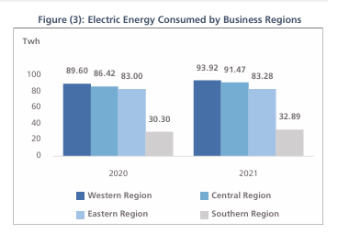

Figure 1: Energy Consumption Saudi Arabia

# METHODOLOGY AND DATA

The project aims to perform a suitability analysis of six different parameters to evaluate potential PV farms in the western region using the Analytic Hierarchy Process (AHP) and Weighted Overlay algorithms to identify desirable regions ranked from 1 to 10 (Figure 2).

## Workflow

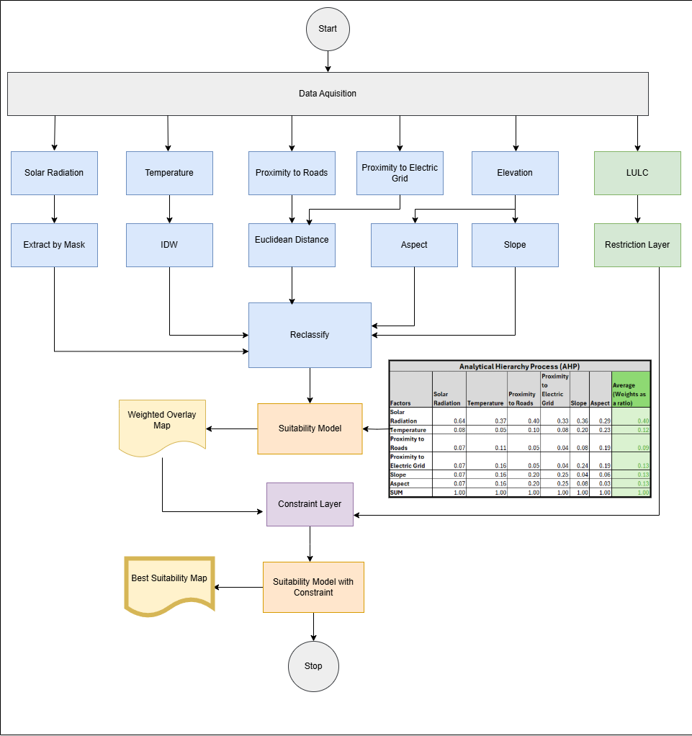

Figure 2: MCDA Workflow

## Study Area and Data Sources

The study area for this project is the western region of Saudi Arabia shown in (Figure 3). The region has a higher consumption of electricity than the central region, even though the population is almost similar. The region lies north of the equator on the west coast of KSA, with the Red Sea and Horn of Africa to its west.

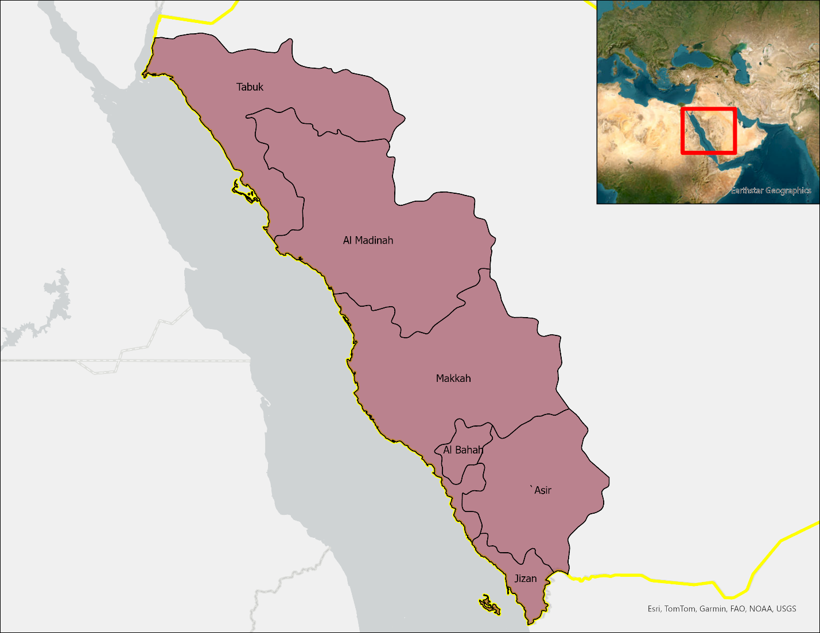

Figure 3: Study Area (Western Provinces of KSA)

Data is collected through various sources and then further preprocessed to meet the analysis requirements. The project aims to create a surface raster of each parameter ranking from 1-10 where one represents the least suitable and ten represents the most suitable. The data sources for all parameters are shown in (Table 1).

|  |  |
| --- | --- |
| Parameters | Data Source |
| Solar PV (Photovoltaic Potential) | Global Solar Atlas |
| Temperature | Open-Meteo |
| Proximity to Roads | MapCruzin |
| Proximity to Existing Electric Grid | Offshore Wind Energy Potential Around the East Coast of the Red Sea, KSA |
| Elevation | USGS EarthExplorer |
| Slope | USGS EarthExplorer, derived from elevation data |
| Aspect | USGS EarthExplorer, derived from elevation data |

Table 1: Data Sources

## Photovoltaic Potential (PV)

The Yearly dataset contains three types of outputs, DNI (Direct Normal Irradiation), GHI (Global Horizontal Irradiation), and PVOUT (Photovoltaic Power Potential). According to most researchers (Al. Garni et al. n.d), GHI is the choice of metric to calculate the PV potential of a region. However, according to a report by the World Bank (World Bank Group, 2020), who are also the creators of the dataset provided by the Global Solar Atlas, the PVOUT metric which has the units KWh/KWp is the preferred metric for assessing the solar potential of a region (see Figure 4). This raster dataset is then reclassified into another dataset from 1-10, where one represents low PV potential and ten represents high PV potential.

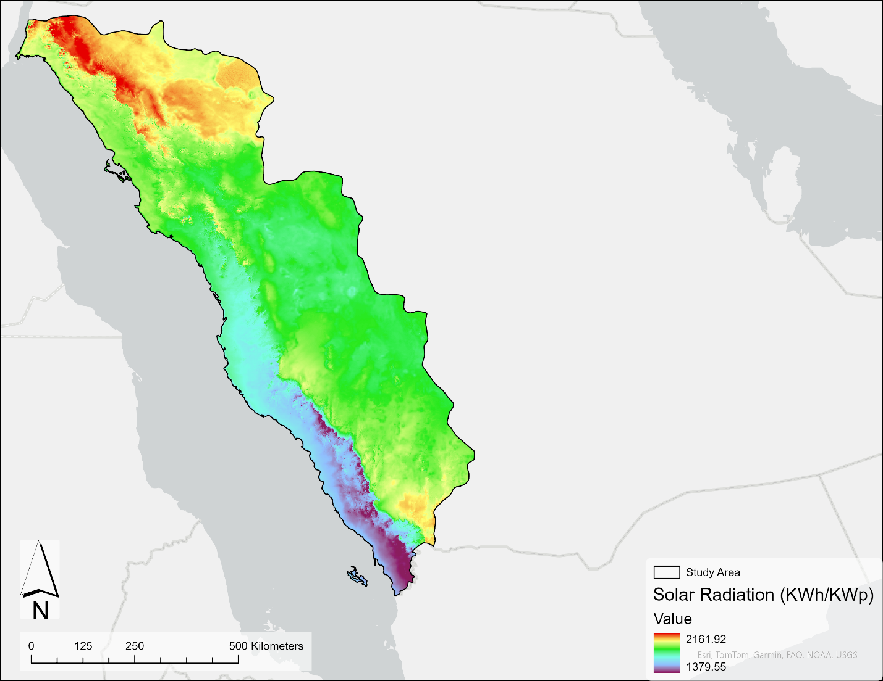

Figure 4: Saudi Solar PV Potential

## Temperature

An increase in temperature above the optimum level of 25°C leads to a reduction in energy by 0.5% per unit increase in temperature (Greentumble, 2024).

The OpenMeteo open-source API gives different kinds of temperature data such as temperature, rainfall, snowfall, windspeed, soil moisture content, and many others. Mean Temperature data can be extracted for a particular location (town or city) using Python API. For this a list of prominent cities is collected and used as an input for the API based on latitude and longitude values (Simplemaps, n.d). After the collection of point temperature data, it is then interpolated into a surface raster using IDW (Inverse Distance Weighting), a common method for approximating temperature surfaces using point vector dataset (Jamie M.Bright, 2019; Kurtzman et al, 1999; Kayıkçı et al, 2016) as shown in (Figure 5). The result is then reclassified on a scale from 1 to 10, where 10 represents the best—lowest average temperature and 1 represents the worst—highest average temperature.

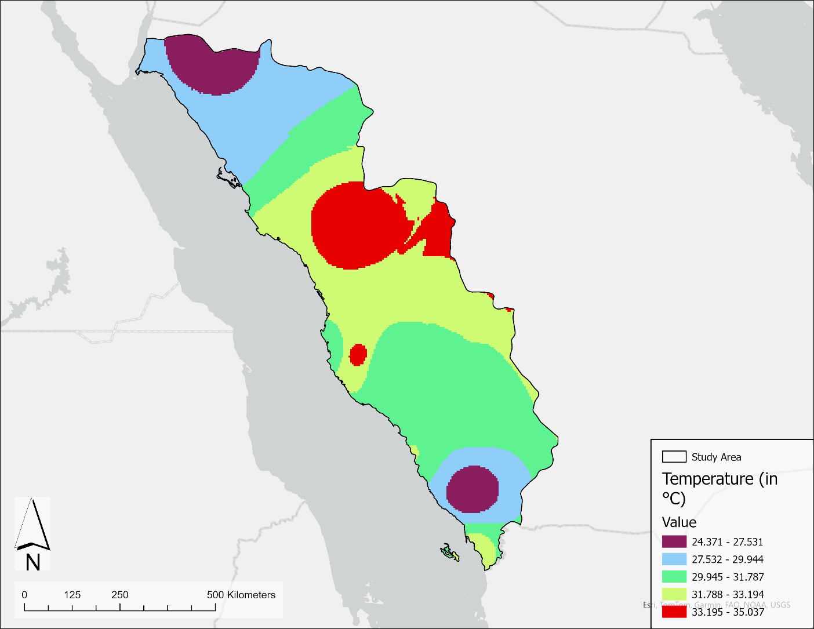

Figure 5: Saudi Arabia average temperature

## Proximity to Roads and Electric Grid

For the transportation network, a Euclidean distance raster is created to best approximate a surface raster with the shortest distance around road networks (Ozelkan et al., 2015; Hong et al, 2015) as shown in (Figure 6).

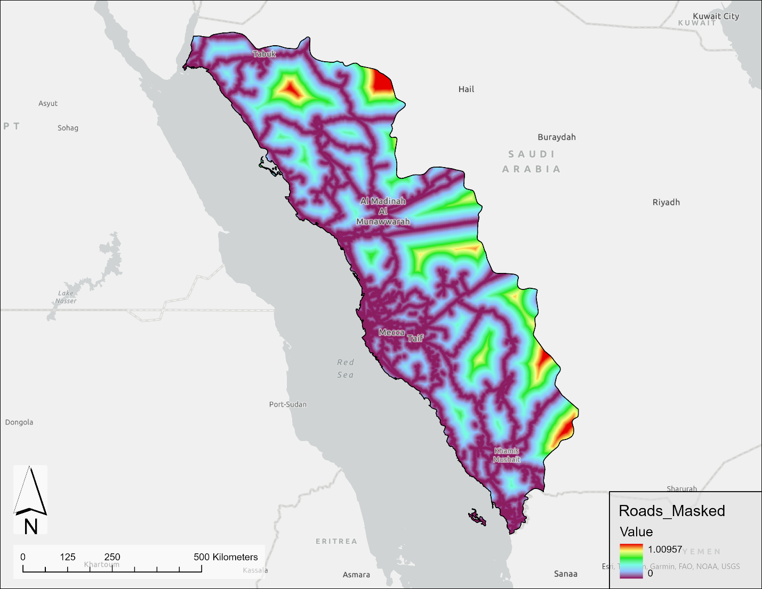

Figure 6: Proximity to Road Networks

For the electric grid, due to the inadequacy of public data available, a sample image was manually georeferenced found here (Mahdy et al, 2017). The process of creating a distance raster is similar to that of the transportation network using the Euclidean Distance algorithm to compute the shortest path raster. The original image and the computed Euclidean raster are shown (Figure 7).

Figure 7: Proximity to Electric Grid

## Elevation, Slope and Aspect

The GMTED2010 dataset which is a large-scale dataset with low spatial resolution (30 arc-seconds ~ 1 km) (USGS, n.d) is appropriate for this analysis as it is computationally less expensive. The mean product is used for this analysis. Desirable outcomes include higher elevation but less steeper slopes. Higher elevation is preferred as air density drops resulting in higher solar irradiance (Nnamchi et al., 2023). Slopes with low steepness are preferred as they increase the cost of installation. The calculation of slope can be done using the DEMs by the formula given below and is shown in (Figure 8):

$$Slope \left(θ\right)=\arctan\left(\frac{y_{i}}{x_{i}}\right)$$

$$θ→Slope or angle of elevation in degrees$$

$${ y}_{i}→Elevation$$

${ x}_{i}→fixed distance on the surface$

The aspect of the direction the surface faces is also calculated using the DEM by the formula below:

$$Aspect \left(θ\right)=\arctan\left(\frac{dz}{dx},-\frac{dz}{dy}\right)$$

$$θ→Apect in degrees from \left(0-360\right)$$

$$dz→change in elevation$$

$$dx→ change in direction of x-coordinate$$

$dy→change in direction of y coordinate$

Since Saudi Arabia lies north of the equator, it is preferred to set up solar panels facing in the southern direction (Kochmarev et al, 2020).

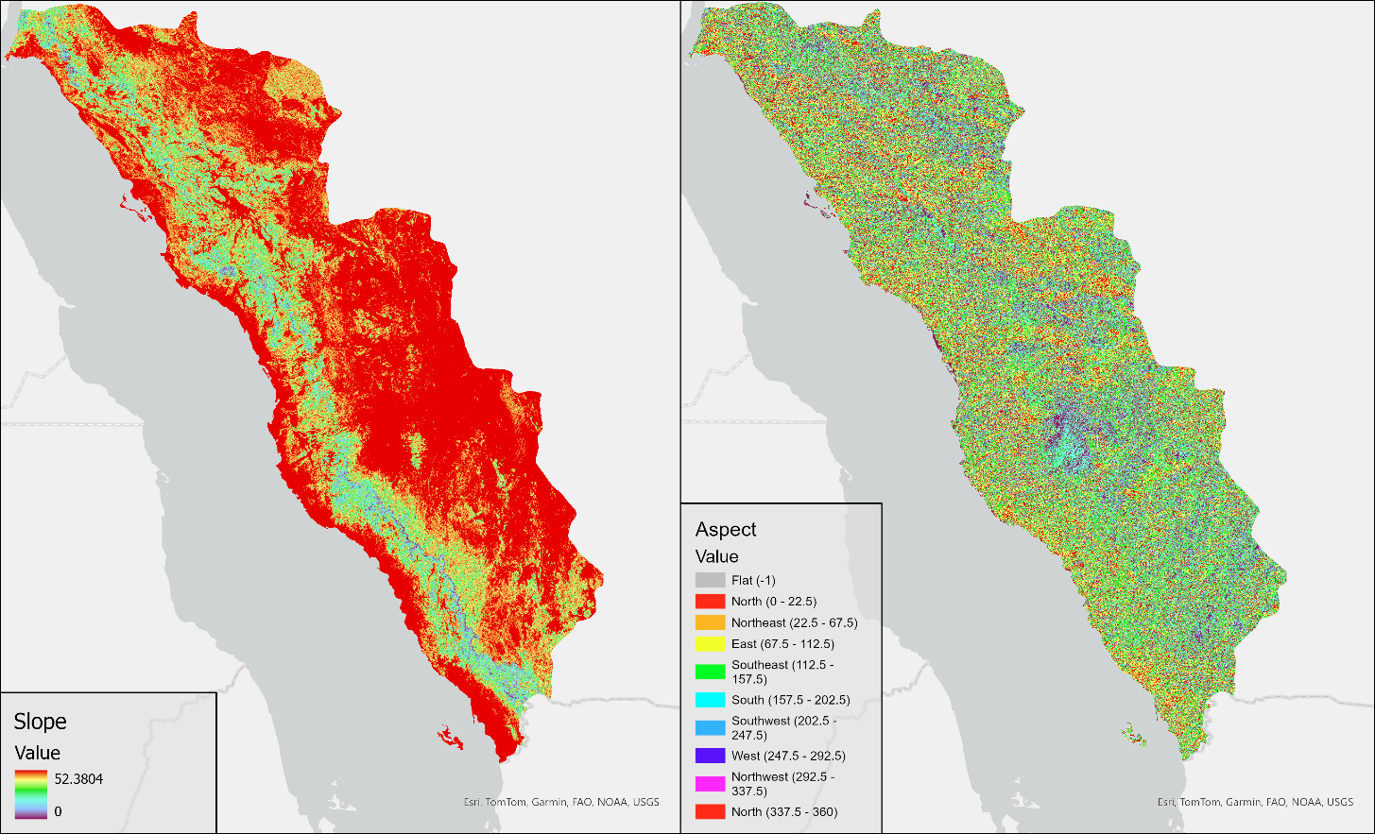

Figure 8: Saudi Arabia Slope and Aspect

## Analytic Hierarchy Process

The Analytic Hierarchy Process (AHP) created by Saaty (1987) is used to evaluate the weights of the parameters to perform a Multi-Criteria Dimensional Analysis (MCDA) based on a normalized pairwise comparison similar to that of a confusion matrix. The process involves pairwise comparisons of criteria and alternatives using a scale of relative importance, which is normalized to generate a set of priority weights as shown in (see Table 2). These weights are then added to the weighted overlay tool to obtain a preliminary suitability map.

|  |  |  |  |  |  |  |  |
| --- | --- | --- | --- | --- | --- | --- | --- |
| Analytical Hierarchy Process (AHP) | | | | | | | |
| Factors | **Solar Radiation** | **Temperature** | **Proximity to Roads** | **Proximity to Electric Grid** | **Slope** | **Aspect** | **Average (Weights as a ratio)** |
| Solar Radiation | 0.64 | 0.37 | 0.40 | 0.33 | 0.36 | 0.29 | 0.40 |
| Temperature | 0.08 | 0.05 | 0.10 | 0.08 | 0.20 | 0.23 | 0.12 |
| Proximity to Roads | 0.07 | 0.11 | 0.05 | 0.04 | 0.08 | 0.19 | 0.09 |
| Proximity to Electric Grid | 0.07 | 0.16 | 0.05 | 0.04 | 0.24 | 0.19 | 0.13 |
| Slope | 0.07 | 0.16 | 0.20 | 0.25 | 0.04 | 0.06 | 0.13 |
| Aspect | 0.07 | 0.16 | 0.20 | 0.25 | 0.08 | 0.03 | 0.13 |
| SUM | 1.00 | 1.00 | 1.00 | 1.00 | 1.00 | 1.00 | 1.00 |

Table 2: AHP

## Constraints Layer

A LULC surface of 16 classes is generated using Landsat 8 imagery and ArcGIS Pro Deep learning model (Figure 9), out of which classes that represent urban landscape, vegetation, and water resources are used to create a constraints layer using the buffer tool (Table 3).

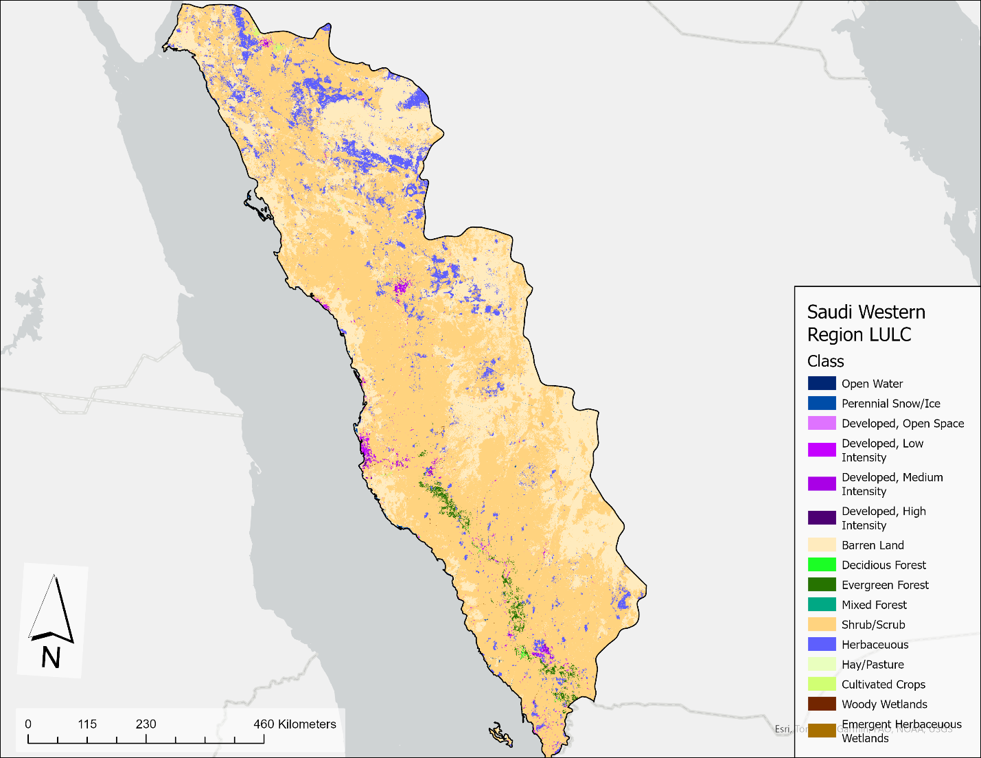

Figure 9: LULC

|  |  |
| --- | --- |
| **Class** | **Status** |
| Open Water | Restricted |
| Perennial Snow/Ice | Restricted |
| Developed, Open Space | Restricted |
| Developed, Low Intensity | Restricted |
| Developed, Medium Intensity | Restricted |
| Developed, High Intensity | Restricted |
| Barren Land | Not Restricted |
| Decidious Forest | Restricted |
| Evergreen Forest | Restricted |
| Mixed Forest | Restricted |
| Shrub/Scrub | Not Restricted |
| Herbaceuous | Not Restricted |
| Hay/Pasture | Not Restricted |
| Cultivated Crops | Not Restricted |
| Woody Wetlands | Restricted |
| Emergent Herbaceuous Wetlands | Restricted |

Table 3: Restricted Classes

# RESULTS AND DISCUSSION

## Parameter Assessment

* Looking at (Figure 4), it can be inferred that the high radiation levels lie in the northern region of Saudi Arabia, and lower values lie in the coastal regions, especially towards the south. Another way to estimate solar PV potential is to use the GHI (Global Horizontal Irradiation) dataset, another common metric to assess PV potential.
* Looking at (Figure 5), it can be said that higher temperature values lie towards the center of the study area and decrease towards the north and south. This analysis can be further improved by using thermal imagery for temperature analysis using the thermal bands (10 &11) of Landsat 8 to interpolate a more accurate raster surface.
* The Slope values for the region are largely flat (They are consistent at an angle of 50°), however, they change suddenly and then decrease towards the west indicating a mountain range. Ideally, this area needs to be avoided, since it is difficult to build and props up the construction cost (see Figure 8).

One way this study can be further enhanced is by using a DEM of higher spatial resolution such as the IKONOS-2 and SPOT-5 datasets (EESA, n.d; EESA, n.d). The resulting dataset would be more specialized and more accurate when calculating slope values.

* For Road Networks, it can be seen (see Figure 6), that most of the region is filled with roads, and the frequency decreases from west to east. Instead of Euclidean Distance, the Cost Distance tool can be employed as well, where further constraining parameters such as elevation can be added, to create a combined layer for better analysis.
* For aspect values, nothing concrete can be concluded, as the entire region seems to have a random distribution of planar orientation.
* It would be helpful if the government stakeholders provided GIS datasets for electric transmission lines to further facilitate this analysis. Similar to the road network component, a Cost Distance tool can be used instead of Euclidean Distance to enhance the study further.

## Constraints Layer

The final constraints layer is shown in (Figure 10). It can be observed that larger portions of the constraint layer lie in the southern part of the study area, close to the border with Yemen, which is primarily due to the abundance of natural vegetation areas in this region.

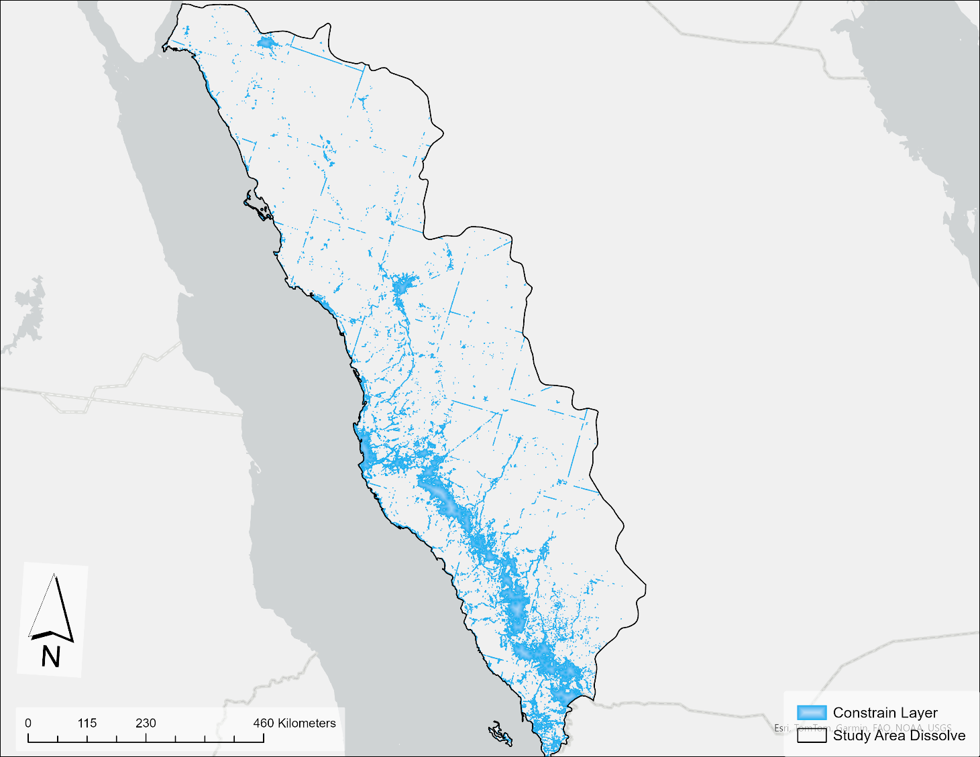

Figure 10: Constraints Layer

## Analytic Hierarchy Process (AHP)

The results with the constraints layer is shown in (Figure 11). According to this model, most regions lie within higher values (9-10). Further filtering of the model, by only taking areas that fall under the suitability index 9 and 10 (see Figure 12), it can be seen that almost the entire northwestern region lies in the suitability zone, with plentiful regions in the southwest as well.

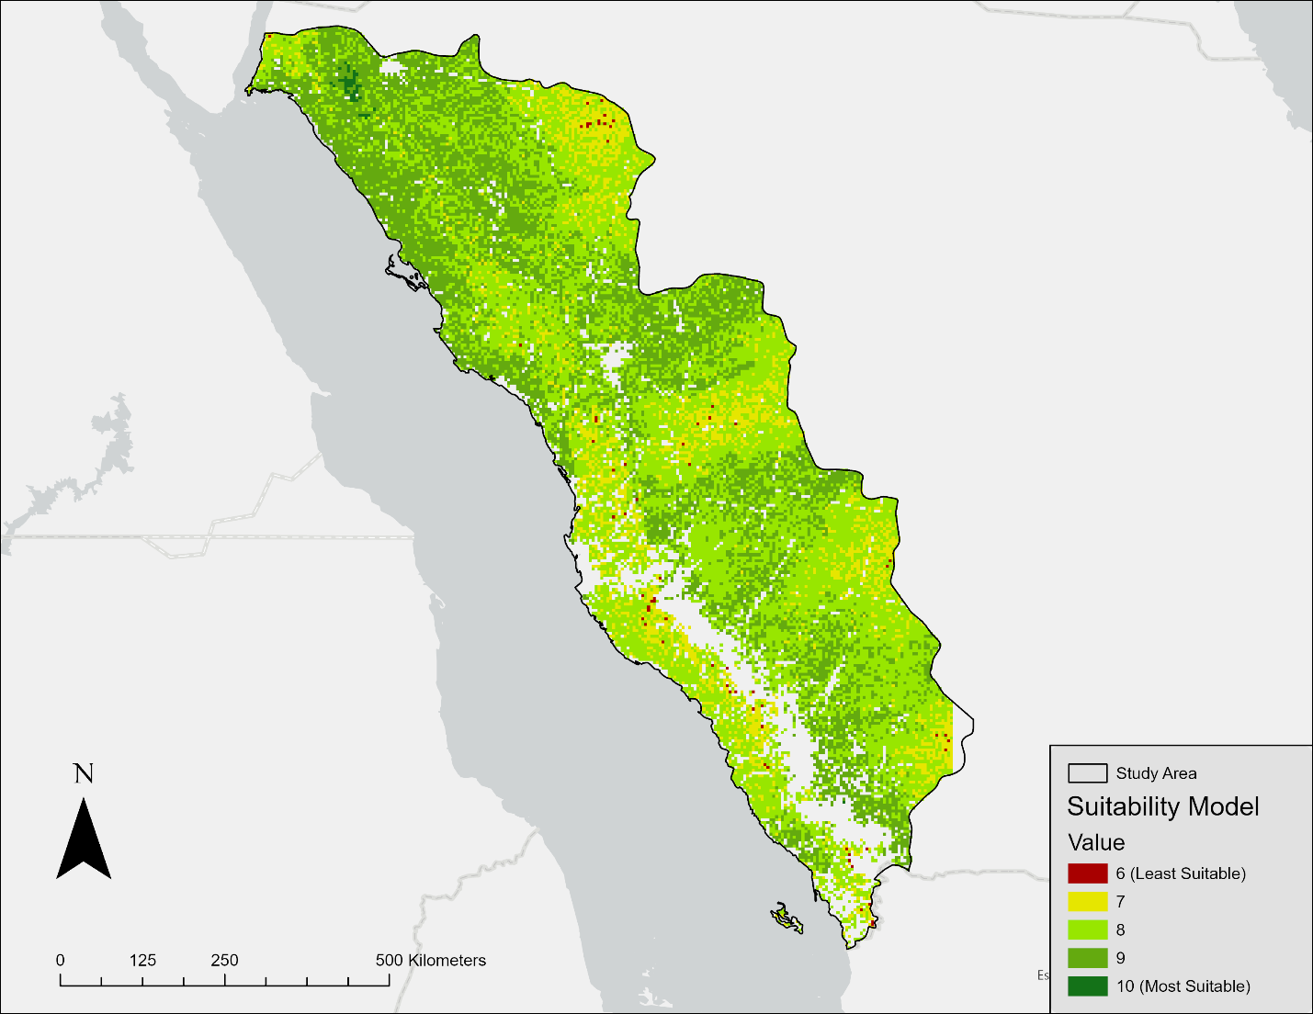

Figure 11: Suitability Model

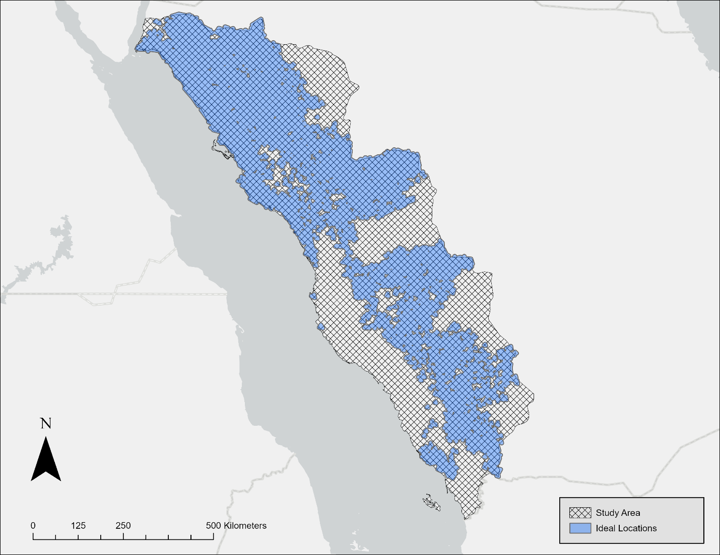

Figure 12: Best Suitability Model

Looking at The Best Suitability Model (Figure 12), the ideal regions lie towards the northwestern province of Tabuk with plentiful regions in the southwest as well. These results correlate well when compared to solar radiation values (see Figure 3, Figure 4).

# CONCLUSION

Assuming only 10% of this area is committed to solar power production, about 10 GW of power can be produced in this region, which is about 87.6 TWh (Terawatt hour) units of energy, about 90% of the energy consumed in the western provinces of KSA. This conclusion is particularly significant given that the Western Region accounted for the largest share of total electrical energy consumption in Saudi Arabia, at 93,920 GWh or 31% of the country's total in 2021.

Implementing large-scale solar projects in the western region could not only help meet local energy demands but also reduce the reliance on fossil fuels for electricity generation. In 2023, natural gas accounted for 62% of electricity generation, while oil accounted for 38%, with renewables contributing less than 1%. By shifting to solar power, Saudi Arabia could potentially free up more of its oil and gas resources for export, supporting its economic diversification efforts.

Moreover, this level of solar power production could help address the increasing electricity consumption in the country, which grew by 6% from 2021 to 2022 and continued to rise in 2023 and early 2024. By focusing on renewable energy sources, Saudi Arabia can meet its growing energy needs while also reducing its carbon footprint and moving towards a more sustainable energy future.

# REFERENCES

American Statistical Association (February 1, 2022) <https://www.amstat.org/your-career/ethical-guidelines-for-statistical-practice>

C. Holiday, (October 24, 2019), “First Photo Taken from Space,” *Space Center Houston.* <https://spacecenter.org/first-photo-taken-from-space/>

CIEC. (2022). <https://www.ceicdata.com/en/saudi-arabia/electricity-statistics/electricity-consumption>

Daniel Kurtzman & Ronen Kadmon. (September 07, 1999). Mapping of temperature variables in Israel: sa comparison of different interpolation methods. <https://www.int-res.com/abstracts/cr/v13/n1/p33-43/>

EESA. (n.d) IKONOS-2 <https://earth.esa.int/eogateway/missions/ikonos-2>

EESA. (n.d) SPOT-5. <https://earth.esa.int/eogateway/missions/spot-5>

Ember. (n.d). Saudi Arabia: Saudi Arabia needs to rapidly increase its renewables share from near zero today to meet its ambitious 2030 targets. <https://ember-climate.org/countries-and-regions/countries/saudi-arabia/>

Global Solar Atlas. (n.d). Global Solar Atlas. <https://globalsolaratlas.info/download?c=21.575719,31.289063,5>

Greentumble. (February 17, 2022). Effect of Temerature on Solar Panel Efficiency. <https://greentumble.com/effect-of-temperature-on-solar-panel-efficiency>

Hassan Z. Al Garni & Anjali Awasthi. (October 31, 2017). Solar PV power plant site selection using a GIS-AHP based approach with application in Saudi Arabia. [https://www.sciencedirect.com/science/article/pii/S030626191731437X \](https://www.sciencedirect.com/science/article/pii/S030626191731437X%20\)

Hong, I., & Murray, A. T. (2016). Assessing Raster GIS Approximation for Euclidean Shortest Path Routing. *Transactions in GIS*, *20*(4), 570-584. <https://doi.org/10.1111/tgis.12160>

Jamie M.Bright. (August 3, 2019). Solcast: Validation of a satellite-dervied solar irradiance dataset. <https://www.sciencedirect.com/science/article/pii/S0038092X19307571>

Kayıkçı. T. Emine & Kazancı. Z. Selma. (Cotober 28, 2016). Comparison of regression-based and combined versions of Inverse Distance Weighted methods for spatial interpolation of daily mean temperature data. <https://link.springer.com/article/10.1007/s12517-016-2723-0>

Kochmarev, K. O., Malozyomov, B. V., Kuznetsova, S. Y., & Ignatev, I. V. (2020). Theory and practice of positioning a solar panel to obtain peak power points at weather stations. *Journal of Physics Conference Series*, *1661*(1), 012098. <https://doi.org/10.1088/1742-6596/1661/1/012098>

Lazard, (June, 2024). Lazard's Levelized Cost of Energy Analysis—Version 2024 <https://www.lazard.com/media/xemfey0k/lazards-lcoeplus-june-2024-_vf.pdf>

Mahdy, Mostafa & Bahaj, AbuBakr & Alghamdi, Abdulsalam. (2017). Offshore Wind Energy Potential Around the East Coast of the Red Sea, KSA. 1-11. 10.18086/swc.2017.38.02.

MapCruzin. (n.d). MapCruzin Data Research & GIS Project Specialist. <https://mapcruzin.com>

Musée Nicéphore Niépce, (n.d). "Heliography: A double invention that revolutionized the world of images,” *Google Arts & Culture.* <https://artsandculture.google.com/story/heliography-a-double-invention-that-revolutionized-the-world-of-images-mus%C3%A9e-nic%C3%A9phore-ni%C3%A9pce/RgUhqRl7dnB3KQ?hl=en>

Neil C. Thompson & Douglas Hanley (n.d). Science is Shaped by Wikipedia: Evidence From a Randomized Control Trial*. <https://ide.mit.edu/sites/default/files/publications/SSRN-id3039505.pdf>

Nick Ferris. (May 3, 2023) Will Saudi Arabia ever make good on its solar ambitions? <https://www.energymonitor.ai/tech/renewables/will-saudi-arabia-ever-make-good-on-its-solar-ambitions/>

Nnamchi, S. N., Natukunda, F., Wanambwa, S., Musiime, E. B., Tukamuhebwa, R., Wanazusi, T., & Ogwal, E. (2023). Effects of wind speed and tropospheric height on solar power generation: Energy exploration above ground level. Energy Reports, 9, 5166–5182. <https://doi.org/10.1016/j.egyr.2023.04.269>

Open-Meteo. (n.d). Historical Weather API. <https://open-meteo.com/en/docs/historical-weather-api#hourly=&daily=temperature_2m_max,temperature_2m_min,temperature_2m_mean,daylight_duration,sunshine_duration>

Ozelkan, E., Bagis, S., Ozelkan, E. C., Ustundag, B. B., Yucel, M., & Ormeci, C. (2015). Spatial interpolation of climatic variables using land surface temperature and modified inverse distance weighting. *International Journal of Remote Sensing*, *36*(4), 1000–1025. <https://doi.org/10.1080/01431161.2015.1007248>

Rahaf Jambi. (July 5, 2024). How Saudi Arabia is harnessing its abundance of renewable energy resources. <https://www.arabnews.com/node/2544306/saudi-arabia>

Saaty, R. (1987). The analytic hierarchy process—what it is and how it is used. *Mathematical Modelling*, *9*(3–5), 161–176. <https://doi.org/10.1016/0270-0255(87)90473-8>

Saudi Electric Company, (2023). Saudi Electricity Company reports a net profit of SAR 5.8 billion in Q3 and increase capital investments by 52% during the first nine months of 2023. <https://www.se.com.sa/en/news/corporatenews/articlefolder/2023/05/26/09/37/corporatenews2410>

Simplemaps. (n.d).Saudi Arabia Cities Database <https://simplemaps.com/data/sa-cities>

The World Factbook. (n.d). “Explore All Countries – Saudi Arabia”. <https://www.cia.gov/the-world-factbook/countries/saudi-arabia/#environment>

USGS. (n.d). U.S Geological Survey, “GMTED2010”. <https://www.usgs.gov/coastal-changes-and-impacts/gmted2010>

Vision 2030, (n.d). Overview. <https://www.vision2030.gov.sa/en/overview>

World Bank Group. (July 23, 2020). Solar Photovoltaic Power Potential by Country <https://www.worldbank.org/en/topic/energy/publication/solar-photovoltaic-power-potential-by-country>

World Bank. (June, 2020). ESMAP, “Global Photovoltaic Power Potential by Country” <https://documents1.worldbank.org/curated/en/466331592817725242/pdf/Global-Photovoltaic-Power-Potential-by-Country.pdf>